**Lab Exercise 1– Install Terraform on Windows**

We need to install terraform on Windows. After installing terraform we need to set the path in environment variables where we had installed the terraform.

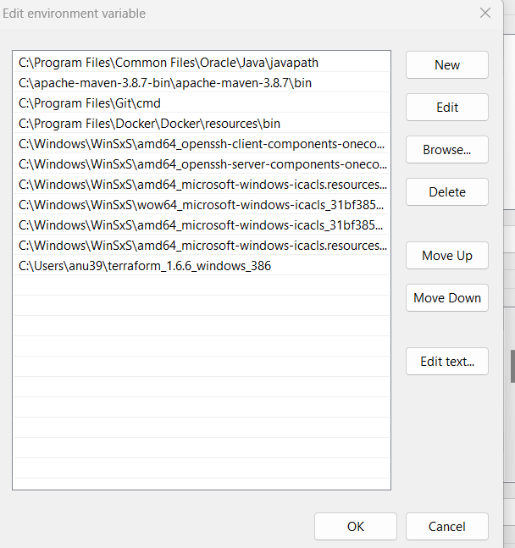

Now check the version of terraform on command prompt.

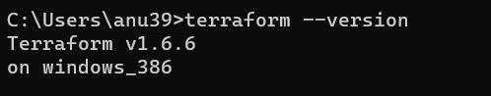

Now, the terraform is installed successfully on your system .